CHG-MERIDIAN Technology and Service Center awarded ISO certification
- Quality and information security standards of entire Gross-Gerau site validated
- ISO 9001 and 27001 certification recognized at international level
- Basis of BSI compliance certification for basic protection in accordance with B1.15 Deletion and Destruction of Data

Weingarten, May 23, 2019

The CHG-MERIDIAN Technology and Service Center has had its information security and quality management processes certified in accordance with international ISO standards 27001 and 9001. The certificates were presented by TÜV Rheinland at the company’s Gross-Gerau site on May 22, 2019.

The international CHG-MERIDIAN Group, based in Weingarten, manages the entire end-of-life process for the IT assets of its customers at its Technology and Service Center in Gross-Gerau. When an asset has reached the end of its economic life, the center erases its data in accordance with the highest security standards. The assets are then professionally refurbished and resold on the secondary market, in line with the principles of sustainable lifecycle management.

The data erasure process eraSURE and its supplementary module eraSURE+ were previously certified by DEKRA and TÜV IT Nord. With this new certification, the auditors from TÜV Rheinland have confirmed that all processes at the entire Gross-Gerau site comply with the highest level of quality and information security, based on the international ISO standard. The certification also formed the basis for certifying BSI compliance in accordance with basic protection module B1.15 (Deletion and Destruction of Data) from the Federal Office for Information Security (BSI).

Klaus Form, Head of Group Service Delivery at CHG-MERIDIAN, said during the presentation: “The key focus of CHG-MERIDIAN is on information security, quality management, and data protection. We are very aware of the trusted status our company enjoys, and of the responsibilities this entails. By certifying the entire Technology and Service Center we are sending a strong signal to our customers and partners in Germany and around the world, while positioning ourselves for the growing competitive challenges.”

In 2018, around 690,000 IT devices, the highest number so far, were professionally refurbished for the secondary market across the Group. In addition to the newly certified Gross-Gerau site, CHG-MERIDIAN operates another Technology and Service Center in Skien (Norway), which is also certified in accordance with the ISO 9001 standard, as well as the ISO 14001 standard. This makes the specialist in independant technology management and financing one of the leading remarketers of IT assets in Europe.

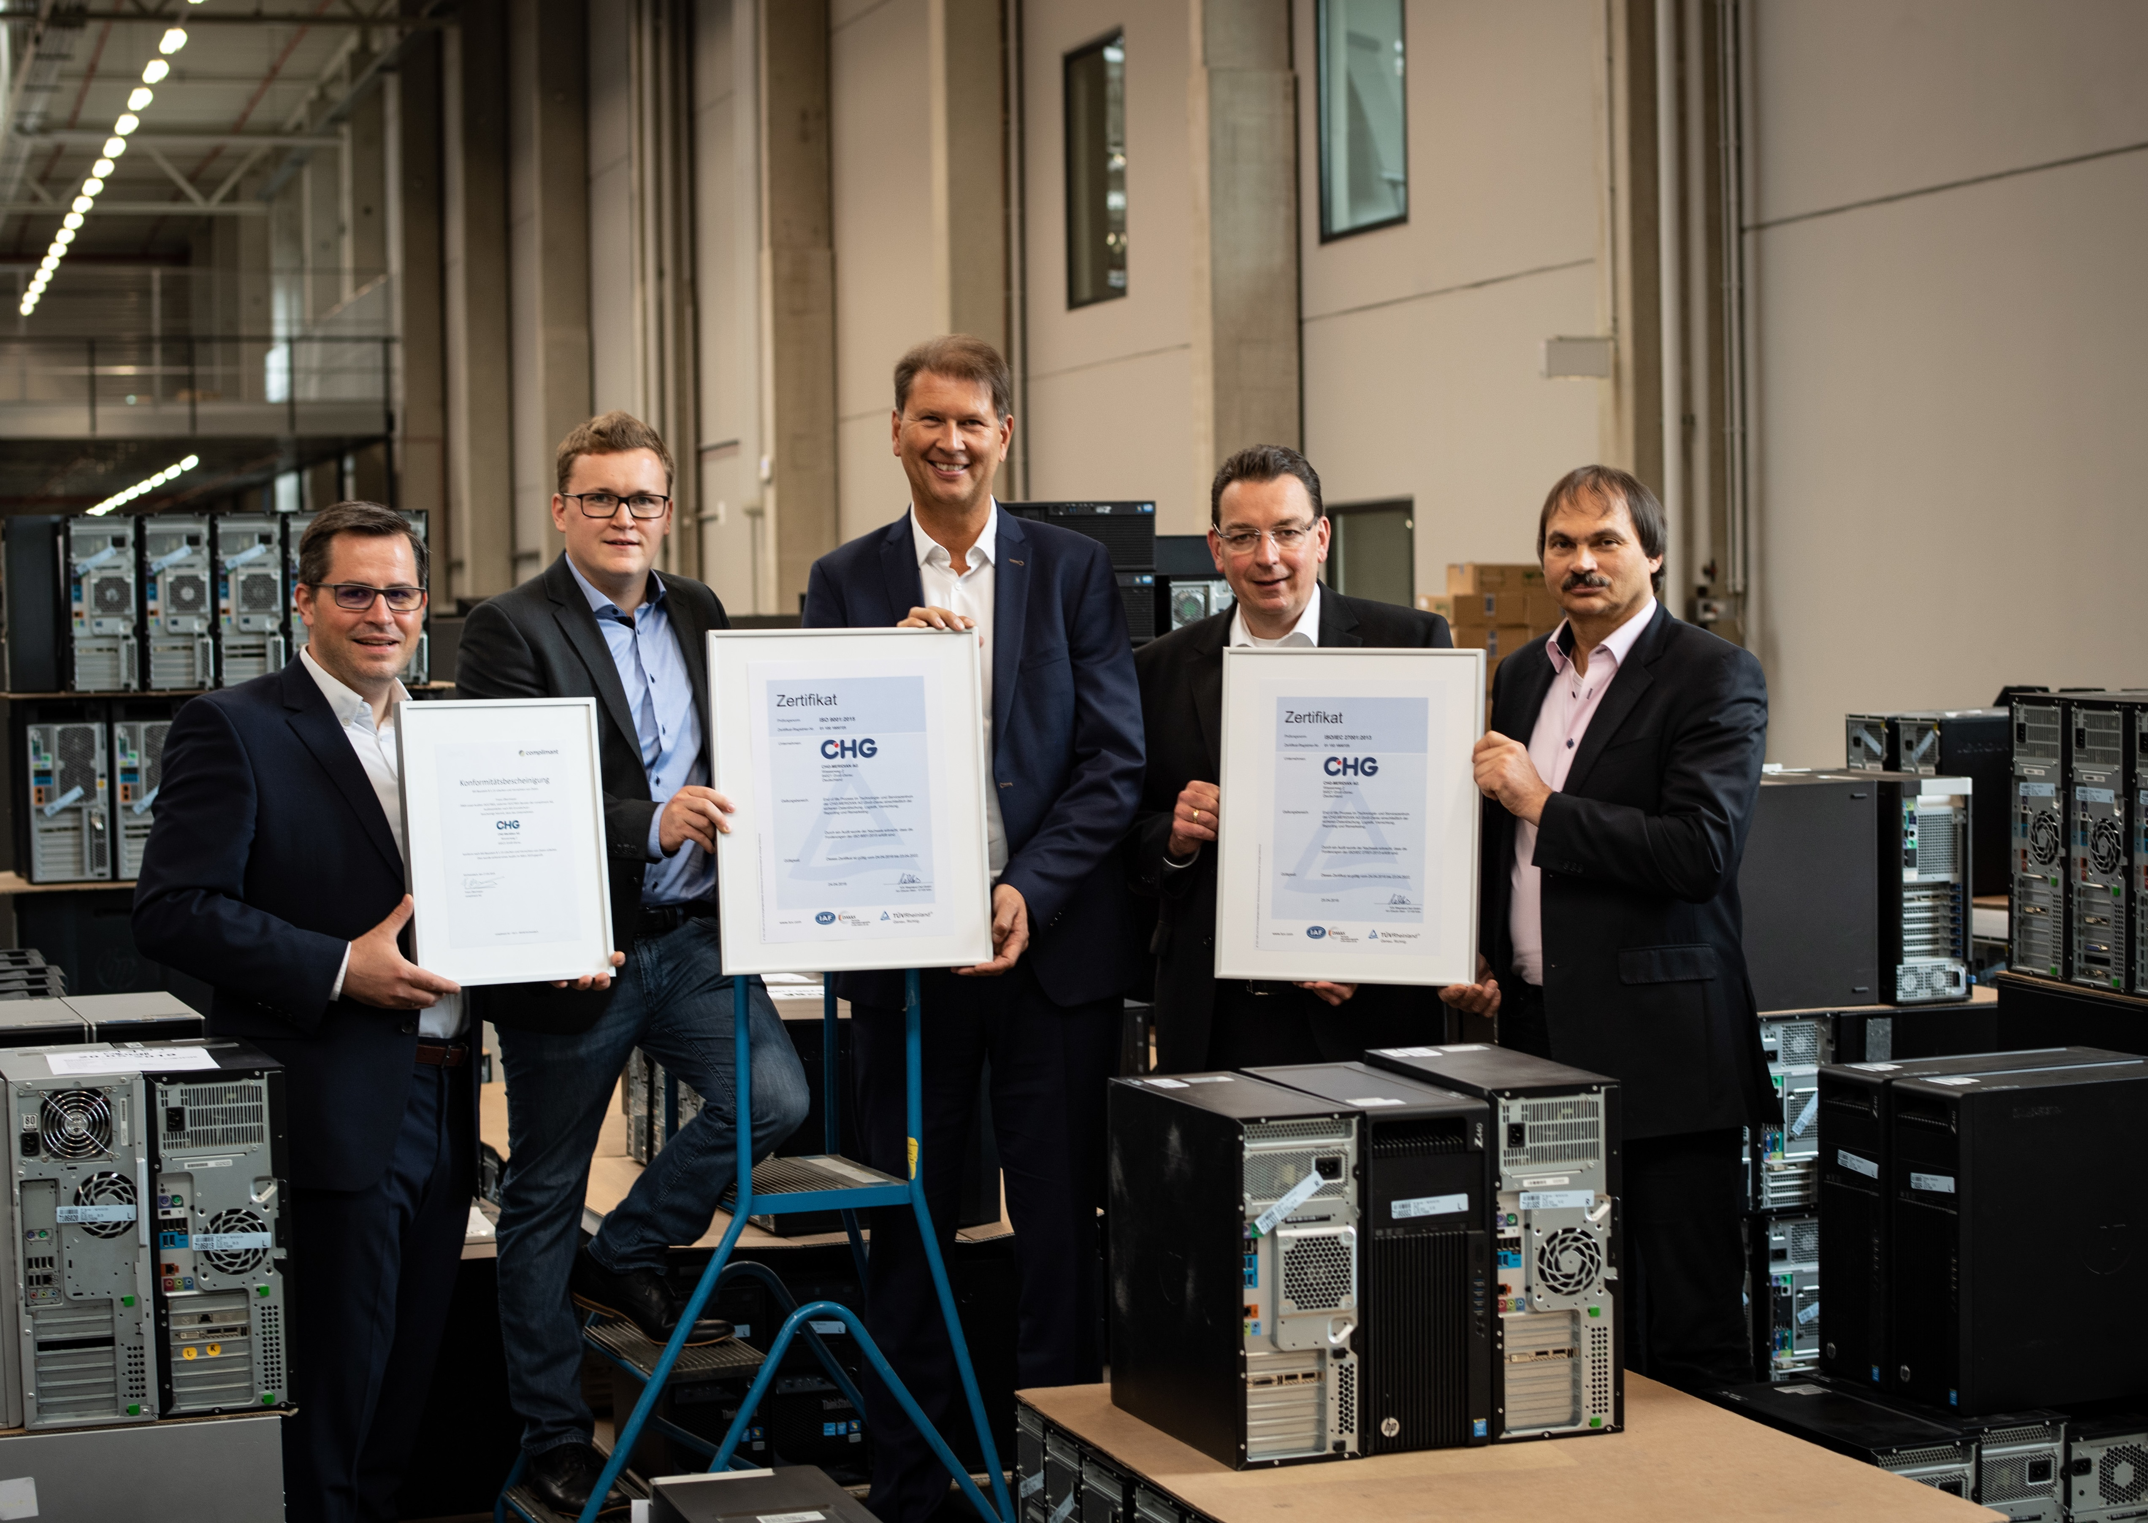

Tobias Wiktorowski (Product Manager), Philipp Frey (IT Consultant), Klaus Form and Alfred Korbmacher (Consultant TZ) from CHG-MERIDIAN received the certificates from Ralph Freude (in the middle) from TÜV Rheinland.

The CHG-MERIDIAN Group

The CHG-MERIDIAN Group is one of the world’s leading non-captive providers of technology management services to the IT, industrial, and healthcare sectors. With some 1,000 employees, the CHG-MERIDIAN Group offers its customers comprehensive support for their technology infrastructure – from consulting, financial, and operational services to used-equipment remarketing services through its two technology and service centers in Germany and Norway.

The CHG-MERIDIAN Group provides efficient technology management for large and medium-sized companies as well as public-sector clients. It now serves more than 10,000 customers worldwide, managing technology investments worth a total of over €4.75 billion. The online-based TESMA® Technology and Service Management System provides more than 15,000 users with maximum transparency in technology management. The CHG-MERIDIAN Group has offices in 25 countries across the globe. Its headquarters are in Weingarten, Germany.

Efficient Technology Management®

